Net 1061 Switching, Routing, and Wireless Essentials

Name:

Lab: # 11.6.2 Switch Security Configuration

Follow the instructions down below for the lab itself. For this lab, all answers need to be in blue font. For the questions right below, answer in complete sentences. You will also have to copy and paste your running configurations of each device configured to the bottom of this document. Let the instructor know if you have any questions.

Lab Analysis Report

1. Using complete sentences summarize work you completed during the lab.
In this lab, I cabled all the devices. Then, I configured the router and switches with basic configurations. Then, I set up the VLANs for both switches and assigned the correct ports to them. Then, I configured the trunking ports. Then, I configured port security settings on the two ports that connect to end devices. Then, I enabled dhcp snooping on S2. Then, I enabled portfast and bpduguard on the two ports that connect to end devices. Finally, I verified connectivity.

2. Using complete sentences describe what you learned from the lab. Hint; look at the lab objectives listed at the top of the lab section.
In this lab I learned more about port security and how implementing certain security measured affects how switches and end devices communicate with each other.

Problems Encountered

1. Using complete sentences describe any problem(s) experienced during lab.
I didn’t experience any problems.

2. Using complete sentences describe how you solved your problem(s).

3. Using complete sentences explain if you needed any assistance with the lab; then list what you learned from that assistance.

Lab - Switch Security Configuration

Topology
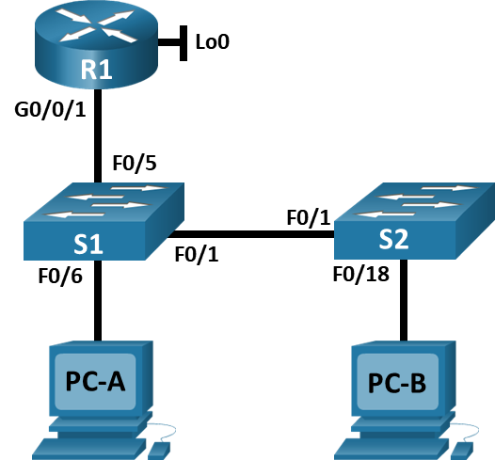

Addressing Table
Device | Interface / VLAN | IP Address | Subnet Mask
R1 | G0/0/1 | 192.168.10.1 | 255.255.255.0
R1 | Loopback 0 | 10.10.1.1 | 255.255.255.0
S1 | VLAN 10 | 192.168.10.201 | 255.255.255.0
S2 | VLAN 10 | 192.168.10.202 | 255.255.255.0
PC – A | NIC | DHCP | 255.255.255.0
PC – B | NIC | DHCP | 255.255.255.0

Objectives
Part 1: Configure the Network Devices.
- Cable the network.
- Configure R1.
- Configure and verify basic switch settings.
Part 2: Configure VLANs on Switches.
- Configure VLAN 10.
- Configure the SVI for VLAN 10.
- Configure VLAN 333 with the name Native on S1 and S2.
- Configure VLAN 999 with the name ParkingLot on S1 and S2.
Part 3: Configure Switch Security.
- Implement 802.1Q trunking.
- Configure access ports.
- Secure and disable unused switchports.
- Document and implement port security features.
- Implement DHCP snooping security.
- Implement PortFast and BPDU guard.
- Verify end-to-end-connectivity.

Background / Scenario
This is a comprehensive lab to review previously covered Layer 2 security features.
Note: The routers used with CCNA hands-on labs are Cisco 4221 with Cisco IOS XE Release 16.9.3 (universalk9 image). The switches used in the labs are Cisco Catalyst 2960s with Cisco IOS Release 15.0(2) (lanbasek9 image). Other routers, switches, and Cisco IOS versions can be used. Depending on the model and Cisco IOS version, the commands available and the output produced might vary from what is shown in the labs. Refer to the Router Interface Summary Table at the end of the lab for the correct interface identifiers.
Note: Make sure that the switches have been erased and have no startup configurations. If you are unsure, contact your instructor.

Required Resources
- 1 Router (Cisco 4221 with Cisco IOS XE Release 16.9.3 universal image or comparable)
- 2 Switches (Cisco 2960 with Cisco IOS Release 15.0(2) lanbasek9 image or comparable)
- 2 PCs (Windows with a terminal emulation program, such as Tera Term)
- Console cables to configure the Cisco IOS devices via the console ports
- Ethernet cables as shown in the topology

Instructions

Configure the Network Devices.

Cable the network.
- Cable the network as shown in the topology.
- Initialize the devices.

Configure R1.
      - Load the following configuration script on R1.
Open configuration window
enable
configure terminal
hostname JCaldwellR1
no ip domain lookup
ip dhcp excluded-address 192.168.10.1 192.168.10.9
ip dhcp excluded-address 192.168.10.201 192.168.10.202
!
ip dhcp pool Students
network 192.168.10.0 255.255.255.0
default-router 192.168.10.1
domain-name CCNA2.Lab-11.6.1
!
interface Loopback0
ip address 10.10.1.1 255.255.255.0
!
interface GigabitEthernet0/0/1
description Link to S1 Port 5
ip dhcp relay information trusted
ip address 192.168.10.1 255.255.255.0
no shutdown
!
line con 0
logging synchronous
exec-timeout 0 0
      - Verify the running-configuration on R1 using the following command:
R1# show ip interface brief
- Verify IP addressing and interfaces are in an up / up state (troubleshoot as necessary).
Close configuration window

Configure and verify basic switch settings.
      - Configure the hostname for switches S1 and S2.
Open configuration window
Open configuration window
      - Prevent unwanted DNS lookups on both switches.
      - Configure interface descriptions for the ports that are in use in S1 and S2.
      - Set the default-gateway for the Management VLAN to 192.168.10.1 on both switches.

Configure VLANs on Switches.

Configure VLAN 10.
Add VLAN 10 to S1 and S2 and name the VLAN Management.

Configure the SVI for VLAN 10.
Configure the IP address according to the Addressing Table for SVI for VLAN 10 on S1 and S2. Enable the SVI interfaces and provide a description for the interface.

Configure VLAN 333 with the name Native on S1 and S2.

Configure VLAN 999 with the name ParkingLot on S1 and S2.

Configure Switch Security.

Implement 802.1Q trunking.
      - On both switches, configure trunking on F0/1 to use VLAN 333 as the native VLAN.
      - Verify that trunking is configured on both switches.
S1# show interface trunk

Port Mode Encapsulation Status Native vlan
Fa0/1 on 802.1q trunking 333

Port Vlans allowed on trunk
Fa0/1 1-4094

Port Vlans allowed and active in management domain
Fa0/1 1,10,333,999

Port Vlans in spanning tree forwarding state and not pruned
Fa0/1 1,10,333,999

S2# show interface trunk

Port Mode Encapsulation Status Native vlan
Fa0/1 on 802.1q trunking 333

Port Vlans allowed on trunk
Fa0/1 1-4094

Port Vlans allowed and active in management domain
Fa0/1 1,10,333,999

Port Vlans in spanning tree forwarding state and not pruned
Fa0/1 1,10,333,999
      - Disable DTP negotiation on F0/1 on S1 and S2.
      - Verify with the show interfaces command.
S1# show interfaces f0/1 switchport | include Negotiation
Negotiation of Trunking: Off

S2# show interfaces f0/1 switchport | include Negotiation
Negotiation of Trunking: Off

Configure access ports.
      - On S1, configure F0/5 and F0/6 as access ports that are associated with VLAN 10.
      - On S2, configure F0/18 as an access port that is associated with VLAN 10.

Secure and disable unused switchports.
      - On S1 and S2, move the unused ports from VLAN 1 to VLAN 999 and disable the unused ports.
      - Verify that unused ports are disabled and associated with VLAN 999 by issuing the show command.
S1# show interfaces status

Port Name Status Vlan Duplex Speed Type
Fa0/1 Link to S2 connected trunk a-full a-100 10/100BaseTX
Fa0/2 disabled 999 auto auto 10/100BaseTX
Fa0/3 disabled 999 auto auto 10/100BaseTX
Fa0/4 disabled 999 auto auto 10/100BaseTX
Fa0/5 Link to R1 connected 10 a-full a-100 10/100BaseTX
Fa0/6 Link to PC-A connected 10 a-full a-100 10/100BaseTX
Fa0/7 disabled 999 auto auto 10/100BaseTX
Fa0/8 disabled 999 auto auto 10/100BaseTX
Fa0/9 disabled 999 auto auto 10/100BaseTX
Fa0/10 disabled 999 auto auto 10/100BaseTX
<output omitted>
S2# show interfaces status

Port Name Status Vlan Duplex Speed Type
Fa0/1 Link to S1 connected trunk a-full a-100 10/100BaseTX
Fa0/2 disabled 999 auto auto 10/100BaseTX
Fa0/3 disabled 999 auto auto 10/100BaseTX
<output omitted>
Fa0/14 disabled 999 auto auto 10/100BaseTX
Fa0/15 disabled 999 auto auto 10/100BaseTX
Fa0/16 disabled 999 auto auto 10/100BaseTX
Fa0/17 disabled 999 auto auto 10/100BaseTX
Fa0/18 Link to PC-B connected 10 a-full a-100 10/100BaseTX
Fa0/19 disabled 999 auto auto 10/100BaseTX
Fa0/20 disabled 999 auto auto 10/100BaseTX
Fa0/21 disabled 999 auto auto 10/100BaseTX
Fa0/22 disabled 999 auto auto 10/100BaseTX
Fa0/23 disabled 999 auto auto 10/100BaseTX
Fa0/24 disabled 999 auto auto 10/100BaseTX
Gi0/1 disabled 999 auto auto 10/100/1000BaseTX
Gi0/2 disabled 999 auto auto 10/100/1000BaseTX

Document and implement port security features.
The interfaces F0/6 on S1 and F0/18 on S2 are configured as access ports. In this step, you will also configure port security on these two access ports.
      - On S1, issue the show port-security interface f0/6 command to display the default port security settings for interface F0/6. Record your answers in the table below.
Default Port Security Configuration
Feature | Default Setting
Port Security | Disabled
Maximum number of MAC addresses | 1
Violation Mode | Shutdown
Aging Time | 0 mins
Aging Type | Absolute
Secure Static Address Aging | Disabled
Sticky MAC Address | 0
      - On S1, enable port security on F0/6 with the following settings:
- Maximum number of MAC addresses: 3
- Violation type: restrict
- Aging time: 60 min
- Aging type: inactivity
      - Verify port security on S1 F0/6.
S1# show port-security interface f0/6
Port Security : Enabled
Port Status : Secure-up
Violation Mode : Restrict
Aging Time : 60 mins
Aging Type : Inactivity
SecureStatic Address Aging : Disabled
Maximum MAC Addresses : 3
Total MAC Addresses : 1
Configured MAC Addresses : 0
Sticky MAC Addresses : 0
Last Source Address:Vlan : 0022.5646.3411:10
Security Violation Count : 0

S1# show port-security address
Secure Mac Address Table
-----------------------------------------------------------------------------
Vlan Mac Address Type Ports Remaining Age
(mins)
---- ----------- ---- ----- -------------
10 0022.5646.3411 SecureDynamic Fa0/6 60 (I)
-----------------------------------------------------------------------------
Total Addresses in System (excluding one mac per port) : 0
Max Addresses limit in System (excluding one mac per port) : 8192
      - Enable port security for F0/18 on S2. Configure the port to add MAC addresses learned on the port automatically to the running configuration.
      - Configure the following port security settings on S2 F/18:
- Maximum number of MAC addresses: 2
- Violation type: Protect
- Aging time: 60 min
      - Verify port security on S2 F0/18.
S2# show port-security interface f0/18
Port Security : Enabled
Port Status : Secure-up
Violation Mode : Protect
Aging Time : 60 mins
Aging Type : Absolute
SecureStatic Address Aging : Disabled
Maximum MAC Addresses : 2
Total MAC Addresses : 1
Configured MAC Addresses : 0
Sticky MAC Addresses : 0
Last Source Address:Vlan : 0022.5646.3413:10
Security Violation Count : 0

S2# show port-security address
Secure Mac Address Table
-----------------------------------------------------------------------------
Vlan Mac Address Type Ports Remaining Age
(mins)
---- ----------- ---- ----- -------------
10 0022.5646.3413 SecureSticky Fa0/18 -
-----------------------------------------------------------------------------
Total Addresses in System (excluding one mac per port) : 0
Max Addresses limit in System (excluding one mac per port) : 8192

Implement DHCP snooping security.
      - On S2, enable DHCP snooping and configure DHCP snooping on VLAN 10.
      - Configure the trunk port on S2 as a trusted port.
      - Limit the untrusted port, F18 on S2, to five DHCP packets per second.
      - Verify DHCP Snooping on S2.
S2# show ip dhcp snooping
Switch DHCP snooping is enabled
DHCP snooping is configured on following VLANs:
10
DHCP snooping is operational on following VLANs:
10
DHCP snooping is configured on the following L3 Interfaces:
Insertion of option 82 is enabled
circuit-id default format: vlan-mod-port
remote-id: 0cd9.96d2.3f80 (MAC)
Option 82 on untrusted port is not allowed
Verification of hwaddr field is enabled
Verification of giaddr field is enabled
DHCP snooping trust/rate is configured on the following Interfaces:

Interface Trusted Allow option Rate limit (pps)
----------------------- ------- ------------ ----------------
FastEthernet0/1 yes yes unlimited
Custom circuit-ids:
FastEthernet0/18 no no 5
Custom circuit-ids:
      - From the command prompt on PC-B, release and then renew the IP address.
C:\Users\Student> ipconfig /release
C:\Users\Student> ipconfig /renew
      - Verify the DHCP snooping binding using the show ip dhcp snooping binding command.
S2# show ip dhcp snooping binding
MacAddress IpAddress Lease(sec) Type VLAN Interface
------------------ --------------- ---------- ------------- ---- --------------------
00:50:56:90:D0:8E 192.168.10.11 86213 dhcp-snooping 10 FastEthernet0/18
Total number of bindings: 1

Implement PortFast and BPDU guard.
      - Configure PortFast on all the access ports that are in use on both switches.
      - Enable BPDU guard on S1 and S2 VLAN 10 access ports connected to PC-A and PC-B.
      - Verify that BPDU guard and PortFast are enabled on the appropriate ports.
S1# show spanning-tree interface f0/6 detail
Port 8 (FastEthernet0/6) of VLAN0010 is designated forwarding
Port path cost 19, Port priority 128, Port Identifier 128.6.
<output omitted for brevity>
Number of transitions to forwarding state: 1
The port is in the portfast mode
Link type is point-to-point by default
Bpdu guard is enabled
BPDU: sent 128, received 0

Verify end-to-end connectivity.
Verify PING connectivity between all devices in the IP Addressing Table. If the pings fail, you may need to disable the firewall on the PC hosts.
Close configuration window

Reflection Questions
  - In reference to Port Security on S2, why is there no timer value for the remaining age in minutes when sticky learning was configured?
When sticky is enabled, the mac addresses get sent to the running configuration meaning that they won’t be affected by the aging.Type your answers here.
  - In reference to Port Security on S2, if you load the running-config script on S2, why will PC-B on port 18 never get an IP address via DHCP?
Since DHCP snooping is enabled, the amount of traffic able to be sent through port 18 is limited.Type your answers here.
  - In reference to Port Security, what is the difference between the absolute aging type and inactivity aging type?
In absolute, the addresses are deleted after a specified amount of time. For inactivity, the addresses are deleted after they are inactive for a specified amount of time.

Paste your configurations here:
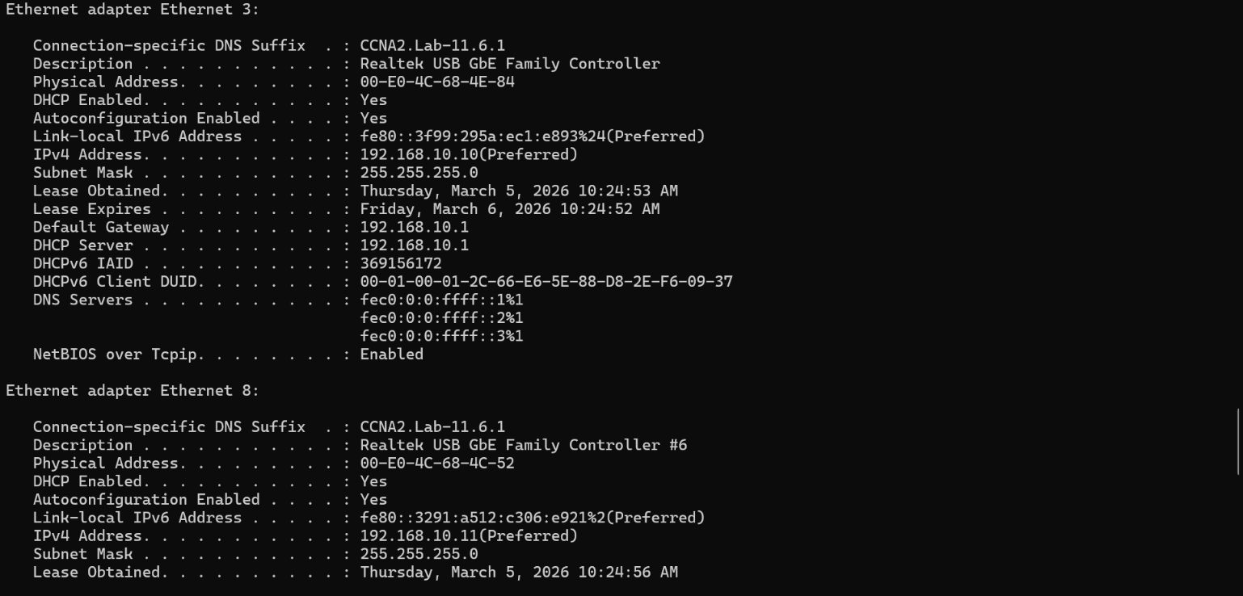
Current configuration : 4862 bytes
!
! Last configuration change at 11:31:32 UTC Thu Mar 5 2026
!
version 15.2
no service pad
service timestamps debug datetime msec
service timestamps log datetime msec
no service password-encryption
!
hostname JCaldwellS1
!
boot-start-marker
boot-end-marker
!
!
no aaa new-model
switch 1 provision c1000-24t-4g-l
system mtu routing 1500
!
!
no ip domain-lookup
!
!
!
!
!
!
crypto pki trustpoint TP-self-signed-3235714944
enrollment selfsigned
subject-name cn=IOS-Self-Signed-Certificate-3235714944
revocation-check none
rsakeypair TP-self-signed-3235714944
!
!
crypto pki certificate chain TP-self-signed-3235714944
certificate self-signed 01
3082022B 30820194 A0030201 02020101 300D0609 2A864886 F70D0101 05050030
31312F30 2D060355 04031326 494F532D 53656C66 2D536967 6E65642D 43657274
69666963 6174652D 33323335 37313439 3434301E 170D3236 30333035 31303339
31345A17 0D333030 31303130 30303030 305A3031 312F302D 06035504 03132649
4F532D53 656C662D 5369676E 65642D43 65727469 66696361 74652D33 32333537
31343934 3430819F 300D0609 2A864886 F70D0101 01050003 818D0030 81890281
8100D4D7 33A2A50E AB8A08F8 323005F0 321BDD7C 079E2E2F AD6C0F11 9B364C52
044B03C2 252D19E7 95136723 A7E0936F 1A265187 520D032D 555F284A 911AB7B2
00502957 FC4AD8CB 5C648F59 090C85F4 38C02FF8 7867F691 FFC41B62 F25191DB
2B7947AF 3EBA0167 5657A95C EDFA22E1 044F7A2C 70B47374 9734A238 23FCE906
83750203 010001A3 53305130 0F060355 1D130101 FF040530 030101FF 301F0603
551D2304 18301680 14D13282 A0D758B2 AE69B3AC 1A955B54 53C3F06B A9301D06
03551D0E 04160414 D13282A0 D758B2AE 69B3AC1A 955B5453 C3F06BA9 300D0609
2A864886 F70D0101 05050003 81810077 C72163B2 E3B6C57D F7BD6221 0483947A
697FAAD2 EE56FD00 53B2033B B161EE10 CD8EEF40 BD79B11B C5A023B2 690A6D2B
303FF6CB 86164548 DE0E2E1D CBBD7767 DA4B8E93 D92FB239 EBD55623 58EEFB27
56E28082 2D37C50C 868D7E65 0E6442C4 A00C9BF5 D4F89DDC 88E24216 BF859B2B
F55B028F 3EE48AA7 2389BC29 E08632
quit
!
spanning-tree mode rapid-pvst
spanning-tree extend system-id
!
vlan internal allocation policy ascending
!
!
!
!
!
!
interface GigabitEthernet1/0/1
description S2 Connection
switchport trunk allowed vlan 1,10,333,999
switchport trunk native vlan 333
switchport mode trunk
switchport nonegotiate
!
interface GigabitEthernet1/0/2
switchport access vlan 999
shutdown
!
interface GigabitEthernet1/0/3
switchport access vlan 999
shutdown
!
interface GigabitEthernet1/0/4
switchport access vlan 999
shutdown
!
interface GigabitEthernet1/0/5
description link to R1
switchport access vlan 10
switchport mode access
!
interface GigabitEthernet1/0/6
description PC-A Connection
switchport access vlan 10
switchport mode access
switchport port-security maximum 3
switchport port-security violation restrict
switchport port-security aging time 60
switchport port-security
spanning-tree portfast edge
spanning-tree bpduguard enable
!
interface GigabitEthernet1/0/7
switchport access vlan 999
shutdown
!
interface GigabitEthernet1/0/8
switchport access vlan 999
shutdown
!
interface GigabitEthernet1/0/9
switchport access vlan 999
shutdown
!
interface GigabitEthernet1/0/10
switchport access vlan 999
shutdown
!
interface GigabitEthernet1/0/11
switchport access vlan 999
shutdown
!
interface GigabitEthernet1/0/12
switchport access vlan 999
shutdown
!
interface GigabitEthernet1/0/13
switchport access vlan 999
shutdown
!
interface GigabitEthernet1/0/14
switchport access vlan 999
shutdown
!
interface GigabitEthernet1/0/15
switchport access vlan 999
shutdown
!
interface GigabitEthernet1/0/16
switchport access vlan 999
shutdown
!
interface GigabitEthernet1/0/17
switchport access vlan 999
shutdown
!
interface GigabitEthernet1/0/18
switchport access vlan 999
shutdown
!
interface GigabitEthernet1/0/19
switchport access vlan 999
shutdown
!
interface GigabitEthernet1/0/20
switchport access vlan 999
shutdown
!
interface GigabitEthernet1/0/21
switchport access vlan 999
shutdown
!
interface GigabitEthernet1/0/22
switchport access vlan 999
shutdown
!
interface GigabitEthernet1/0/23
switchport access vlan 999
shutdown
!
interface GigabitEthernet1/0/24
switchport access vlan 999
shutdown
!
interface GigabitEthernet1/0/25
switchport access vlan 999
shutdown
!
interface GigabitEthernet1/0/26
switchport access vlan 999
shutdown
!
interface GigabitEthernet1/0/27
switchport access vlan 999
shutdown
!
interface GigabitEthernet1/0/28
switchport access vlan 999
shutdown
!
interface Vlan1
ip dhcp client client-id ascii cisco-98a2.c0dd.17c0-Vl1
no ip address
shutdown
!
interface Vlan10
description management vlan
ip address 192.168.10.201 255.255.255.0
!
ip default-gateway 192.168.10.1
ip http server
ip http secure-server
!
!
!
!
line con 0
line vty 0 4
login
transport input none
line vty 5 15
login
transport input none
!
End

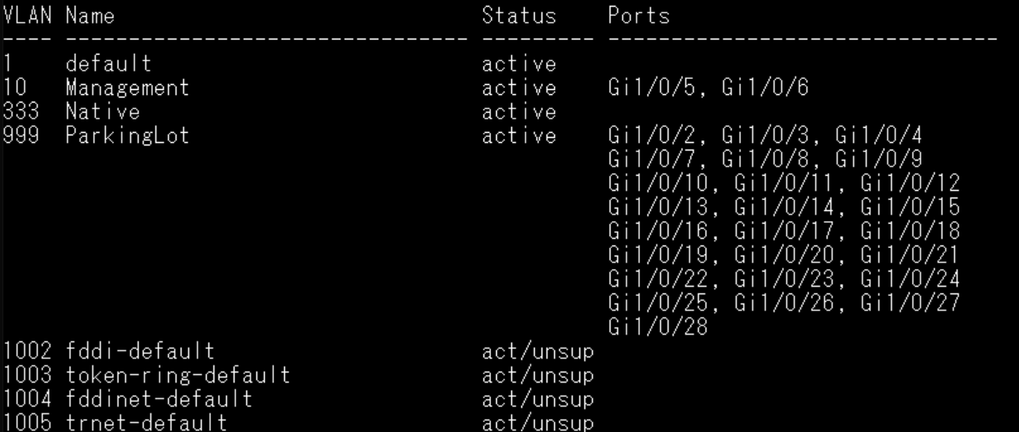

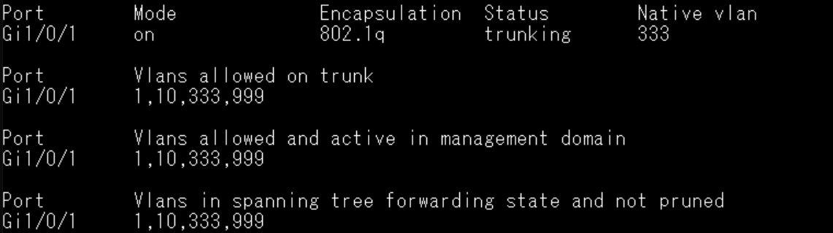
Current configuration : 5013 bytes
!
! Last configuration change at 16:07:27 UTC Thu Mar 5 2026
!
version 15.2
no service pad
service timestamps debug datetime msec
service timestamps log datetime msec
no service password-encryption
!
hostname JCaldwellS2
!
boot-start-marker
boot-end-marker
!
!
no aaa new-model
switch 1 provision c1000-24t-4g-l
system mtu routing 1500
!
!
ip dhcp snooping vlan 10
ip dhcp snooping
no ip domain-lookup
!
!
!
!
!
!
crypto pki trustpoint TP-self-signed-3069817600
enrollment selfsigned
subject-name cn=IOS-Self-Signed-Certificate-3069817600
revocation-check none
rsakeypair TP-self-signed-3069817600
!
!
crypto pki certificate chain TP-self-signed-3069817600
certificate self-signed 01
3082022B 30820194 A0030201 02020101 300D0609 2A864886 F70D0101 05050030
31312F30 2D060355 04031326 494F532D 53656C66 2D536967 6E65642D 43657274
69666963 6174652D 33303639 38313736 3030301E 170D3236 30333035 31353333
32395A17 0D333030 31303130 30303030 305A3031 312F302D 06035504 03132649
4F532D53 656C662D 5369676E 65642D43 65727469 66696361 74652D33 30363938
31373630 3030819F 300D0609 2A864886 F70D0101 01050003 818D0030 81890281
8100AC98 B18DFA88 FE59EE52 DC6AE755 7DEF292C 3B0FF149 C176DCDF 3F1F54AB
7C9BC64E 5316F7F2 809589EC 2A2EF17C 83E25E40 1A51BC79 B86D0D6A AAD47659
415A46F8 1896444C 2593556A 3BDDD569 2C662C96 E2E9C80D 9BD528C3 43FE4B52
C05A0755 EF95CBCF A6BCCE02 FA0F4F52 80FA19A6 433019ED 13D5AA07 AAA63989
3F130203 010001A3 53305130 0F060355 1D130101 FF040530 030101FF 301F0603
551D2304 18301680 14EEFF62 8E119072 219E3E94 29063F7F F0E00EF1 80301D06
03551D0E 04160414 EEFF628E 11907221 9E3E9429 063F7FF0 E00EF180 300D0609
2A864886 F70D0101 05050003 81810074 9E52B442 4B074633 6ED496D0 D250152F
29B0849D 32D8776A BA7CF644 07418E20 01F52504 B427C2A1 1D77237B 0FCE5DAD
337D407B 4183445B 1202FA12 B769BADD 07626ADC BB615AC2 B3DD934C 1D8989FE
E54C4ED9 A47C450C 5257C1D5 5696A2F2 ED5BDF8A 0B595CB1 FEAA7FC1 066F462D
E21C4B70 D85ACCD6 9CDE1BC3 633EE5
quit
!
spanning-tree mode rapid-pvst
spanning-tree extend system-id
!
vlan internal allocation policy ascending
!
!
!
!
!
!
interface GigabitEthernet1/0/1
description S1 Connection
switchport trunk allowed vlan 1,10,333,999
switchport trunk native vlan 333
switchport mode trunk
switchport nonegotiate
ip dhcp snooping trust
!
interface GigabitEthernet1/0/2
switchport access vlan 999
shutdown
!
interface GigabitEthernet1/0/3
switchport access vlan 999
shutdown
!
interface GigabitEthernet1/0/4
switchport access vlan 999
shutdown
!
interface GigabitEthernet1/0/5
switchport access vlan 999
shutdown
!
interface GigabitEthernet1/0/6
switchport access vlan 999
shutdown
!
interface GigabitEthernet1/0/7
switchport access vlan 999
shutdown
!
interface GigabitEthernet1/0/8
switchport access vlan 999
shutdown
!
interface GigabitEthernet1/0/9
switchport access vlan 999
shutdown
!
interface GigabitEthernet1/0/10
switchport access vlan 999
shutdown
!
interface GigabitEthernet1/0/11
switchport access vlan 999
shutdown
!
interface GigabitEthernet1/0/12
switchport access vlan 999
shutdown
!
interface GigabitEthernet1/0/13
switchport access vlan 999
shutdown
!
interface GigabitEthernet1/0/14
switchport access vlan 999
shutdown
!
interface GigabitEthernet1/0/15
switchport access vlan 999
shutdown
!
interface GigabitEthernet1/0/16
switchport access vlan 999
shutdown
!
interface GigabitEthernet1/0/17
switchport access vlan 999
shutdown
!
interface GigabitEthernet1/0/18
description PC-B Connection
switchport access vlan 10
switchport mode access
switchport port-security maximum 2
switchport port-security violation protect
switchport port-security mac-address sticky
switchport port-security mac-address sticky 00e0.4c68.4c52
switchport port-security aging time 60
switchport port-security
spanning-tree portfast edge
spanning-tree bpduguard enable
ip dhcp snooping limit rate 5
!
interface GigabitEthernet1/0/19
switchport access vlan 999
shutdown
!
interface GigabitEthernet1/0/20
switchport access vlan 999
shutdown
!
interface GigabitEthernet1/0/21
switchport access vlan 999
shutdown
!
interface GigabitEthernet1/0/22
switchport access vlan 999
shutdown
!
interface GigabitEthernet1/0/23
switchport access vlan 999
shutdown
!
interface GigabitEthernet1/0/24
switchport access vlan 999
shutdown
!
interface GigabitEthernet1/0/25
switchport access vlan 999
shutdown
!
interface GigabitEthernet1/0/26
switchport access vlan 999
shutdown
!
interface GigabitEthernet1/0/27
switchport access vlan 999
shutdown
!
interface GigabitEthernet1/0/28
switchport access vlan 999
shutdown
!
interface Vlan1
ip dhcp client client-id ascii FOC2749Y818
no ip address
shutdown
!
interface Vlan10
description Management Vlan
ip address 192.168.10.202 255.255.255.0
!
ip default-gateway 192.168.10.1
ip http server
ip http secure-server
!
!
!
!
line con 0
line vty 0 4
login
transport input none
line vty 5 15
login
transport input none
!
End
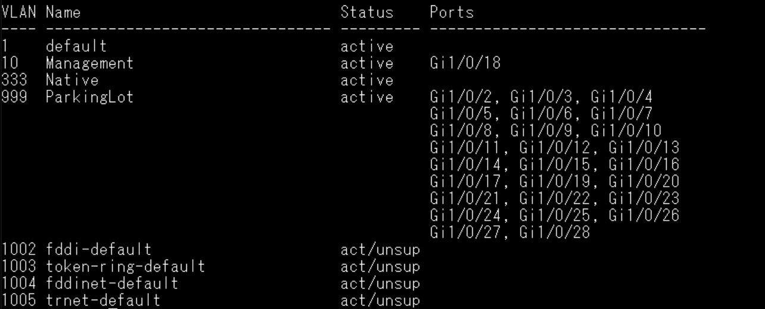
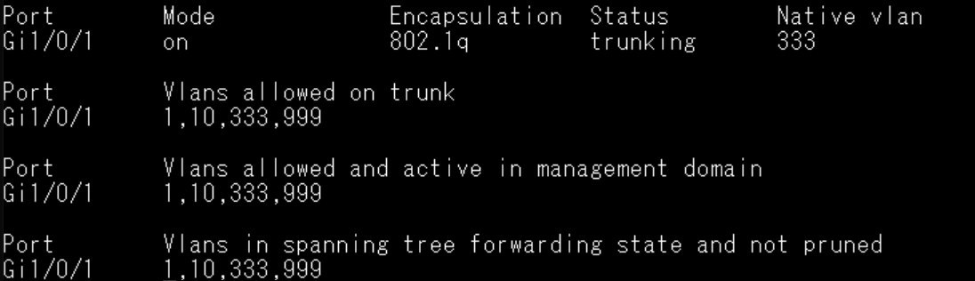

Current configuration : 6373 bytes
!
! Last configuration change at 16:46:52 UTC Thu Mar 5 2026
!
version 17.3
service timestamps debug datetime msec
service timestamps log datetime msec
! Call-home is enabled by Smart-Licensing.
service call-home
platform qfp utilization monitor load 80
platform punt-keepalive disable-kernel-core
!
hostname JCaldwellR1
!
boot-start-marker
boot-end-marker
!
!
vrf definition Mgmt-intf
!
address-family ipv4
exit-address-family
!
address-family ipv6
exit-address-family
!
!
no aaa new-model
!
!
!
!
!
!
!
no ip domain lookup
ip dhcp excluded-address 192.168.10.1 192.168.10.9
ip dhcp excluded-address 192.168.10.201 192.168.10.202
!
ip dhcp pool Students
network 192.168.10.0 255.255.255.0
default-router 192.168.10.1
domain-name CCNA2.Lab-11.6.1
!
!
!
login on-success log
!
!
!
!
!
!
!
subscriber templating
multilink bundle-name authenticated
no device-tracking logging theft
!
!
!
crypto pki trustpoint TP-self-signed-2037616329
enrollment selfsigned
subject-name cn=IOS-Self-Signed-Certificate-2037616329
revocation-check none
rsakeypair TP-self-signed-2037616329
!
crypto pki trustpoint SLA-TrustPoint
enrollment pkcs12
revocation-check crl
!
!
crypto pki certificate chain TP-self-signed-2037616329
certificate self-signed 01
30820330 30820218 A0030201 02020101 300D0609 2A864886 F70D0101 05050030
31312F30 2D060355 04031326 494F532D 53656C66 2D536967 6E65642D 43657274
69666963 6174652D 32303337 36313633 3239301E 170D3236 30333035 31363034
35385A17 0D333630 33303431 36303435 385A3031 312F302D 06035504 03132649
4F532D53 656C662D 5369676E 65642D43 65727469 66696361 74652D32 30333736
31363332 39308201 22300D06 092A8648 86F70D01 01010500 0382010F 00308201
0A028201 0100CA74 9AB45F9C 30C7EF8F AB1B0342 29483556 DD6C7667 8009CEC7
FB0D06DC 0F9F61A6 DA4838E8 8C83B2C4 F83DE908 88DB3CC3 DA7777C5 E366B855
075ABDAB E6C077FD E42702F9 5F7BC0D6 612442FF E660B8EF A50D811F DE822745
4B2B3BAD 9425E1C4 DC00D1E1 48D8DFE0 326BA272 4C1E394A 2DDCB0B9 9A88544D
BF0E65EB A1A816CA 35DE05DB 551744B0 2D0806C5 1A78E1C0 C9489461 9BE9CF35
969F7FA3 E4AB6476 266C813D A5B448F2 D3D74DC0 C7B6FEB2 CB8B2074 EBA1F74E
4E1B5909 B96BAF94 F585CBDA 6BAC2EF5 7014814A D373F528 CA75A5D1 73BB04A0
EEA7E26D B930D8EA 8453B6E9 0203AA52 85B9D613 F738F3BA FB4F0963 E0C6F79A
86BD7162 41430203 010001A3 53305130 0F060355 1D130101 FF040530 030101FF
301F0603 551D2304 18301680 1401E0FF 0126743F 29C358AB 3B3451C6 152B2875
54301D06 03551D0E 04160414 01E0FF01 26743F29 C358AB3B 3451C615 2B287554
300D0609 2A864886 F70D0101 05050003 82010100 87ED0755 22BE3613 056C8ECD
0019014A 55DDF7C3 E3590BA7 D12EA98C C72B4BD5 58076A9E B466E06F 615E2355
99A49806 6FFB9EA4 8D3E5773 1AE065B1 EBF1802D 15552399 C398183D AB388613
BC7401BA 24AF41C6 9F95B808 1C043EE5 343681E7 A799C417 1BB50852 2D309CE7
29021CFE 71B67275 40E1633E 5FA4E775 271B0BBC 597FD052 FD023707 49A11683
E8B44F30 A3A7928C 63A03A9C 18199BBD A5871661 775AC5FB D22A8AFD 5CAE2927
000AE455 82DBE92F C0AF2CBF 90FCF034 E13633CD C1159BE6 DE585122 92664D29
9C505C72 B857E0B9 A43B528E F833275D 12EC81FA 39F1F035 693D159A 8D8F034B
3264A1F3 A21A3F81 AC3F880C 34A98B73 B11CA6F0
quit
crypto pki certificate chain SLA-TrustPoint
certificate ca 01
30820321 30820209 A0030201 02020101 300D0609 2A864886 F70D0101 0B050030
32310E30 0C060355 040A1305 43697363 6F312030 1E060355 04031317 43697363
6F204C69 63656E73 696E6720 526F6F74 20434130 1E170D31 33303533 30313934
3834375A 170D3338 30353330 31393438 34375A30 32310E30 0C060355 040A1305
43697363 6F312030 1E060355 04031317 43697363 6F204C69 63656E73 696E6720
526F6F74 20434130 82012230 0D06092A 864886F7 0D010101 05000382 010F0030
82010A02 82010100 A6BCBD96 131E05F7 145EA72C 2CD686E6 17222EA1 F1EFF64D
CBB4C798 212AA147 C655D8D7 9471380D 8711441E 1AAF071A 9CAE6388 8A38E520
1C394D78 462EF239 C659F715 B98C0A59 5BBB5CBD 0CFEBEA3 700A8BF7 D8F256EE
4AA4E80D DB6FD1C9 60B1FD18 FFC69C96 6FA68957 A2617DE7 104FDC5F EA2956AC
7390A3EB 2B5436AD C847A2C5 DAB553EB 69A9A535 58E9F3E3 C0BD23CF 58BD7188
68E69491 20F320E7 948E71D7 AE3BCC84 F10684C7 4BC8E00F 539BA42B 42C68BB7
C7479096 B4CB2D62 EA2F505D C7B062A4 6811D95B E8250FC4 5D5D5FB8 8F27D191
C55F0D76 61F9A4CD 3D992327 A8BB03BD 4E6D7069 7CBADF8B DF5F4368 95135E44
DFC7C6CF 04DD7FD1 02030100 01A34230 40300E06 03551D0F 0101FF04 04030201
06300F06 03551D13 0101FF04 05300301 01FF301D 0603551D 0E041604 1449DC85
4B3D31E5 1B3E6A17 606AF333 3D3B4C73 E8300D06 092A8648 86F70D01 010B0500
03820101 00507F24 D3932A66 86025D9F E838AE5C 6D4DF6B0 49631C78 240DA905
604EDCDE FF4FED2B 77FC460E CD636FDB DD44681E 3A5673AB 9093D3B1 6C9E3D8B
D98987BF E40CBD9E 1AECA0C2 2189BB5C 8FA85686 CD98B646 5575B146 8DFC66A8
467A3DF4 4D565700 6ADF0F0D CF835015 3C04FF7C 21E878AC 11BA9CD2 55A9232C
7CA7B7E6 C1AF74F6 152E99B7 B1FCF9BB E973DE7F 5BDDEB86 C71E3B49 1765308B
5FB0DA06 B92AFE7F 494E8A9E 07B85737 F3A58BE1 1A48A229 C37C1E69 39F08678
80DDCD16 D6BACECA EEBC7CF9 8428787B 35202CDC 60E4616A B623CDBD 230E3AFB
418616A9 4093E049 4D10AB75 27E86F73 932E35B5 8862FDAE 0275156F 719BB2F0
D697DF7F 28
quit
!
!
license udi pid ISR4321/K9 sn FLM254904JP
memory free low-watermark processor 69075
!
diagnostic bootup level minimal
!
spanning-tree extend system-id
!
!
redundancy
mode none
!
!
!
!
!
!
!
!
interface Loopback0
ip address 10.10.1.1 255.255.255.0
!
interface GigabitEthernet0/0/0
no ip address
shutdown
negotiation auto
!
interface GigabitEthernet0/0/1
description Link to S1 Port 5
ip dhcp relay information trusted
ip address 192.168.10.1 255.255.255.0
negotiation auto
!
interface GigabitEthernet0
vrf forwarding Mgmt-intf
no ip address
shutdown
negotiation auto
!
ip http server
ip http authentication local
ip http secure-server
ip forward-protocol nd
ip tftp source-interface GigabitEthernet0
!
!
!
!
!
!
control-plane
!
!
line con 0
exec-timeout 0 0
logging synchronous
stopbits 1
line aux 0
stopbits 1
line vty 0 4
login
transport input ssh
!
call-home
! If contact email address in call-home is configured as sch-smart-licensing@cisco.com
! the email address configured in Cisco Smart License Portal will be used as contact email address to send SCH notifications.
contact-email-addr sch-smart-licensing@cisco.com
profile "CiscoTAC-1"
active
destination transport-method http
!
!
!
!
!
!
end

